

CSA0501-DATABASE MANAGEMENT SYSTEMS

LAB EXPERIMENTS DATE: 14/08/2026

EXPERIMENT 20– MYSQL STRING FUNCTION

AIM: To implement REPLACE, REPEAT, REVERSE, RIGHT, LEFT, RPAD, LPAD, ASCII, BIN and OCT string functions using MySQL.

PROCEDURE:
- Select the pet_management database.
- Display the existing records from the pet_details table.
- Apply string functions to the pet_name column.
- Execute REPLACE(), REPEAT(), and REVERSE() functions.
- Execute RIGHT(), LEFT(), RPAD(), and LPAD() functions.
- Execute ASCII(), BIN(), and OCT() functions.
- Verify the results displayed by each function.

PROGRAM:

Display all records

SELECT * FROM pet_details;
OUTPUT:

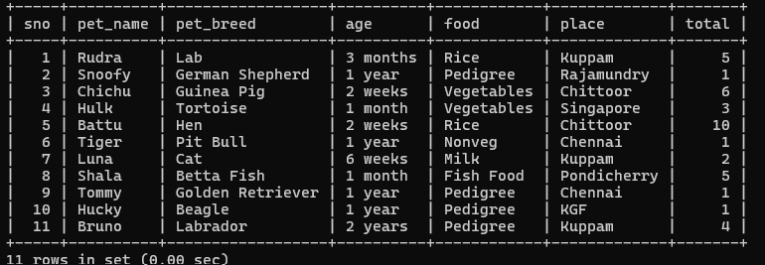

2. REPLACE()

SELECT pet_name, REPLACE(pet_name, 'a', 'A') AS replaced_name

FROM pet_details;
OUTPUT:

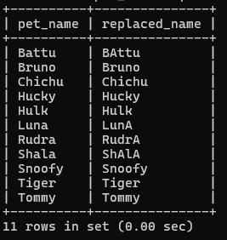

3. REPEAT()

SELECT pet_name, REPEAT(pet_name, 2) AS repeated_name

FROM pet_details;
OUTPUT:
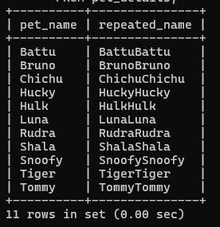

4. REVERSE()

SELECT pet_name, REVERSE(pet_name) AS reversed_name

FROM pet_details;
OUTPUT:
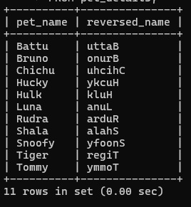

5. RIGHT()

SELECT pet_name, RIGHT(pet_name, 3) AS right_characters

FROM pet_details;
OUTPUT:
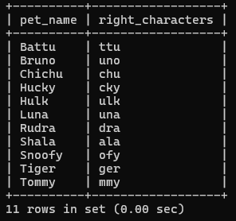

6. LEFT()

SELECT pet_name, LEFT(pet_name, 3) AS left_characters

FROM pet_details;
OUTPUT:
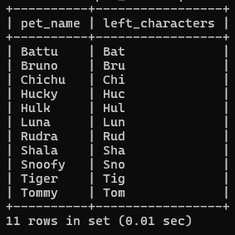

7. RPAD()

SELECT pet_name, RPAD(pet_name, 15, '*') AS right_padded

FROM pet_details;
OUTPUT:
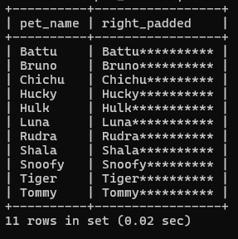

8. LPAD()

SELECT pet_name, LPAD(pet_name, 15, '*') AS left_padded

FROM pet_details;
OUTPUT:
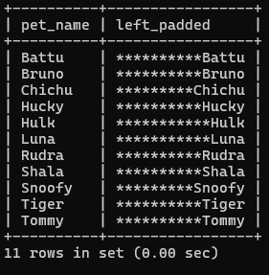

9. ASCII()

SELECT pet_name, ASCII(pet_name) AS ascii_value

FROM pet_details;
OUTPUT:
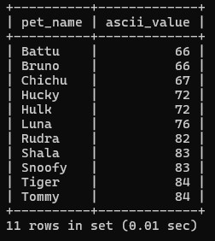

10. BIN()

SELECT sno, BIN(sno) AS binary_value

FROM pet_details;
OUTPUT:

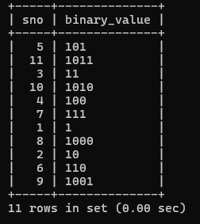

11. OCT()

SELECT sno, OCT(sno) AS octal_value

FROM pet_details;
OUTPUT:
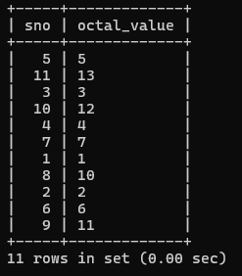

RESULT: The MySQL string functions REPLACE, REPEAT, REVERSE, RIGHT, LEFT, RPAD, LPAD, ASCII, BIN and OCT were executed successfully and the required results were obtained.

